***COVID NIRAMAY COVID NIRAMAY COVID NIRAMAY***

***⦁ University of Engineering and Management , kolkata*** ⦁ ***UEMK***

**COVID NIRAMAY**

**University of Engineering and Management , Kolkata**





* **App Description :**
* It's an Android App which has both desktop and mobile versions.
* It's known as COVID-19 UEM.
* It has some animations in different parts of the app which awares us about the precautions that we should take against the Corona Virus Pandemic.
* On the preface, it awares us about the statistics of the number of people suffering directly from the disease on a global scale.
* **App Features :**
* **Module 1 : COVID-19 Dashboard by the JHU CSSE –** It provides the Statistical Data of Total Country-wise Confirmed cases, total deaths , etc from SARS-COV19 Virus infection with different plots and Ghaphical analysis .
* **Module 2 : DISASTER MANAGEMENT :** It provides us with the disaster management helpline numbers and other details to cop up with the extreme Pandamic Situation . It has four sub-modules :

* **Sub-Module I : BLOOD BANKS:** It gives us all a list of blood banks across India . It also provides their websites , contact numbers ; etc.
* **Sub-Module II : HEALTH MINISTRY WEBSITES :** It gives us a list of websites of all States and Union Territories of India .
* **Sub-Module III : HOSPITAL DETAILS :** Here , we have created a Website by ourselves , which gives all the hospital and ambulance contacts of all the States and Union Territories of India .
* **Sub-Module IV : PHARMACY NEARBY :** This gives the list of all possible pharmacies present near anyone based on his/her location.
* **Module 3 : News -** It awares us of the recent treading news about all states of India and the NATIONAL COVID-19 Pandemic news , which are all around, on the social Media . It provides us with :

1. **STATE-WISE NEWS.**
2. **NATIONAL NEWS.**

* **Module 4 : Donate -**  It provides us with an opportunity with the list of all State Chief Minister funds and Prime Minister Care Fund for donations for relief against the Pandemic.
* **Module 5 : Emergency Numbers-** It gives us a list of some government Service phone numbers which will help us informing the Government about emergency conditions on a short notice. Along with this this provides a List of all state

Help-line numbers. The numbers will be automatically dialed once clicked.The numbers are ;

1. Police Station number
2. Railway Enquiry number
3. COVID Helpline number
4. Senior Citizen Helpline number
5. Fire Service number
6. Diasaster Management number
7. Child Helpline number
8. National Helpline number
9. AIDS H Helpline number

* **Module 6 : Create Appointment and Self-test -** It provides us with two unique features which are as follows :
* **Sub-Module I : Create Appointment -** It provides us an opportunity to book an appointment with eminent doctors through the online platform .
* **Sub-Module II :**  **CoVID-19 Self-test -** Itprovides us with an opportunity to a self-test online to see of a person is prone to SARS COVID-19 Virus and weather he/she visit the hospital if neccessary .
* **Module 7 : TRANSPORT FACILITIES :** It holds every possible informations about transport options. It also has various sub-modules . They are as follows :
* **Sub-Module I : IRCTC WEBSITE FOR RAILWAYS :** It gives us all possible informations about Indian railways.
* **Sub-Module II : FLIGHT ENQUIRY :** It gives us all possible informations about Indian airlines.
* **Sub-Module III : BUS SERVICES :** It gives us all possible informations about Indian bus services.
* **Sub-Module IV : CABS AND TAXIS :** Any online cabs like OLA or UBER cabs can be booked from here.
* **Module 8 : MORE -**  The " MORE " botton provides us with an opportunity to learn about this Corona Virus and learn about the guidelines against this Viral outbreak ; it further provides us with :
* **Sub-Module I :** The WHO regulations .
* **Sub-Module II :** Some popular and mostly asked FAQ about COVID-19.
* **Sub-Module III :**  Transactions. It holds every possible bank related informations . It has two parts . They are as follows :

1. **BANKS :**  A list of special CoVID-19 featured websites of all possible Banks of India , explaining their special schemes.
2. **E-WALLETS:** A list of online payment platforms for online money transactions .

* **Sub-Module IV :** All food Shelters near any Consumer's Location.
* **Sub-Module V :** The different Biological Data about COVID-19.
* **Sub-Module VI :** A list of different Educational courses related to COVID-19 and other Topics, designed especially for students to do something fruitful in their Quarantine time .
* **Sub -Module VII :** A list of guidelines and advices for migratory laborers in the Quarantine time .
* **Sub-Module VIII :** Report Cases of COVID-19 . All Helpline numbers of the 28 different States and 8 different Union Territories of India.
* **Sub-Module IX :** A document specifying the List of Contamination Zones as per the Government of India .
* **Sub-Module X : Volunteer Registration :** A Government of India Website where , interested people can enroll as Volunteers.
* **Sub-Module X I: COVID-19 LET'S TRACK IT :** It is a Servey form which tells the Consumer weather he is prone to COVID-19 Viral Infection and which creates a database of the Consumers who are Safe , Prone or affected to SARS-COV-2 Virus .
* **Module 9 : BUY ITEMS -** The " BUY ITEMS " named button provides us with an opportunity to buy items online . The sub-Modules are :
* **Sub-Module I :** It allows the Consumer to buy Groceries online . Two online platforms are provided for this purpose :

1. **GROFERS : ONLINE SHOPPING SITE.**
2. **BIGBASKET : ONLINE SHOPPING SITE.**

* **Sub-Module II :** It allows the Consumer to buy Medicines online . Two online platforms are provided for this purpose :

1. **MEDPLUSMART : ONLINE SITE FOR BUYING MEDICINES.**
2. **MEDPLUSMART : ONLINE SITE FOR BUYING MEDICINES.**

* **Module 10 : OTHERS -** This provides a lot of additional informations about the Virus . The Sub-Modules here are :
* **Sub-Module I :** The names of the students who have developed this app .
* **Sub-Module II :** The State-wise COVID-19 Statistics of all States and Union Territories of India . The State-wise number of Confirmed cases , Active cases , Recovered Cases and Death cases are specified here .
* **Sub-Module III :** The World-wise COVID-19 Statistics of all countries globally . The State-wise number of Confirmed cases , Active cases , Recovered Cases and Death cases are specified here .
* **Sub-Module IV : "BIOLOGICAL DATA" :** This again Containsmany sub-modules . External links are provided here .They are as follows:

1. Public Health Informations about COVID-19 Virus.
2. A video demonstration about how soap kills coronavirus.
3. Detailed information on CoVID-19 Viral Infrmation.
4. Biologial 3-D Structures of different CoVID related Viral Proteins.
5. More Detailed Information about Corona Proteases.
6. The different Country wise viral sequences.
7. More Information on SARS-COV-2 Spike Protein .
8. A short video on CoVID-19 Transmission .

* **APP SCREENSHOTS OF DIFFERENT MODULES –**

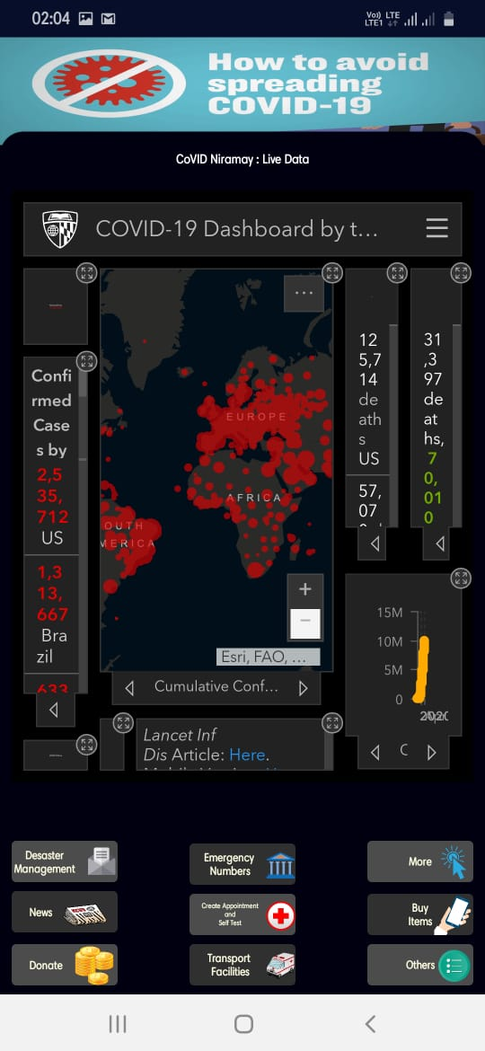

***App Interface***

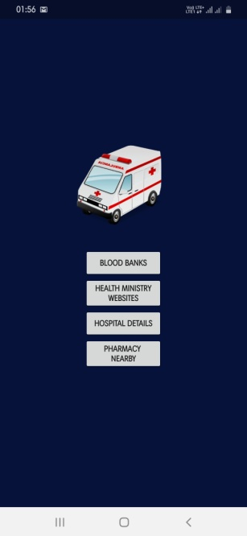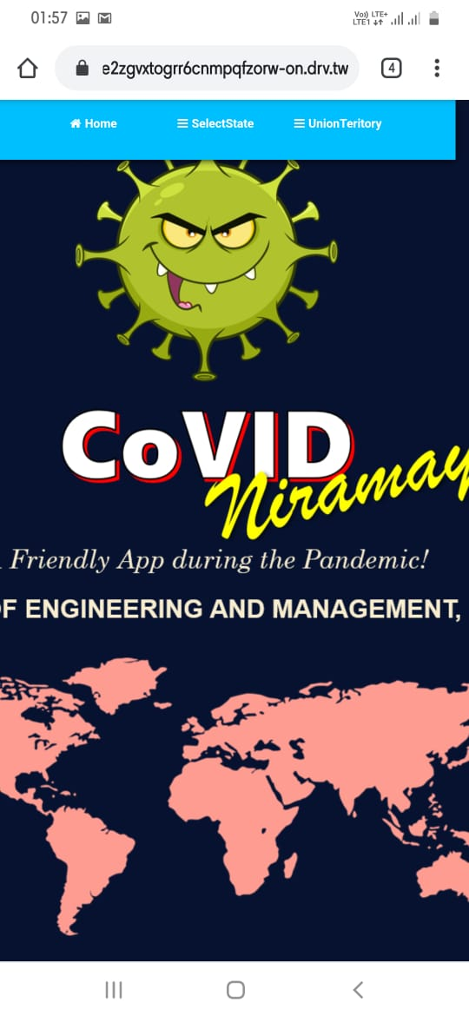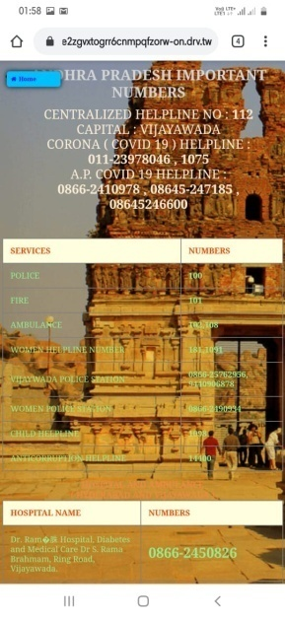

***Disaster Management Module Screenshots***

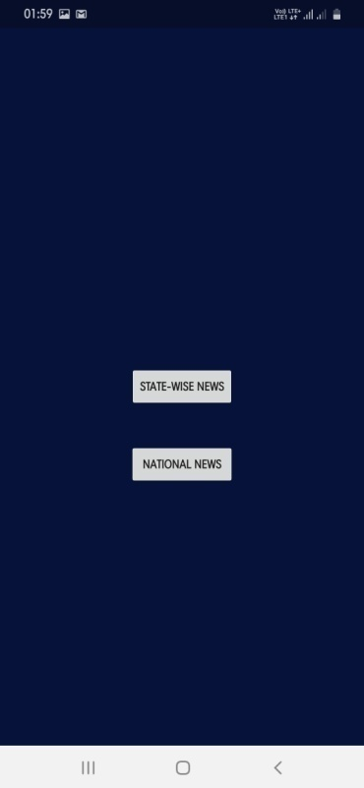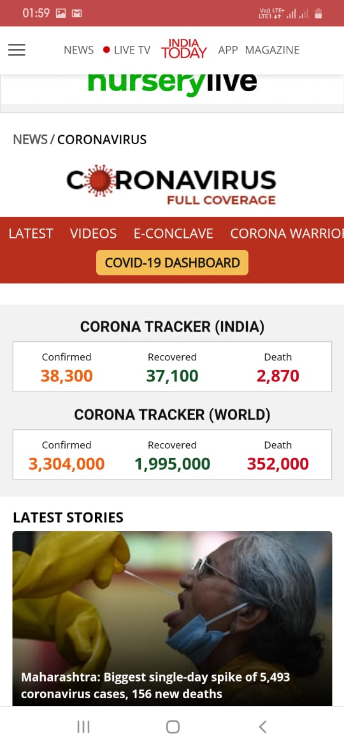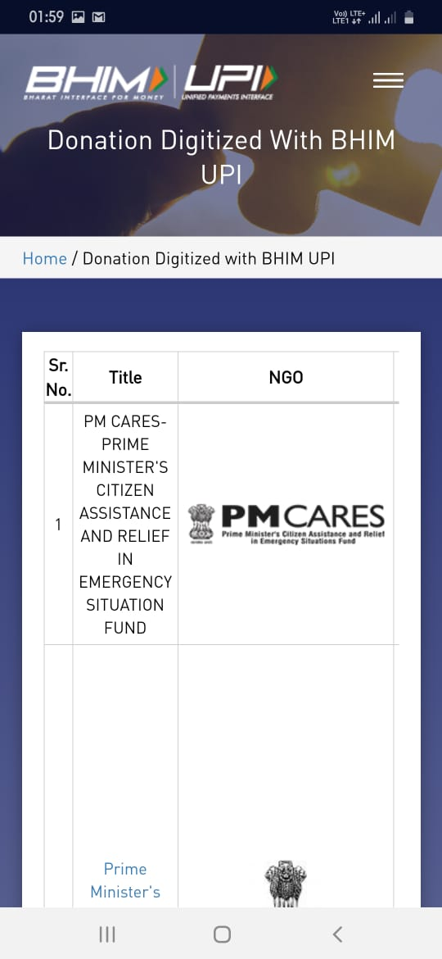

***News & Donation Module Screenshots***

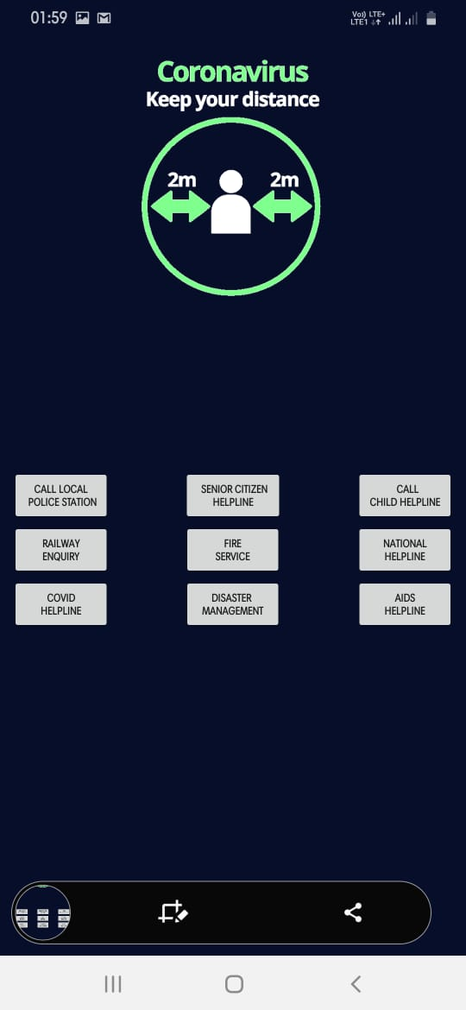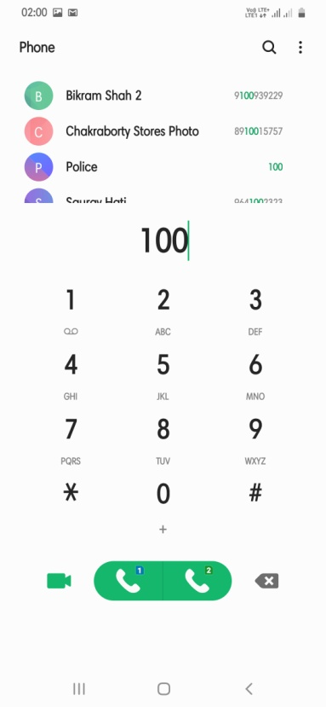 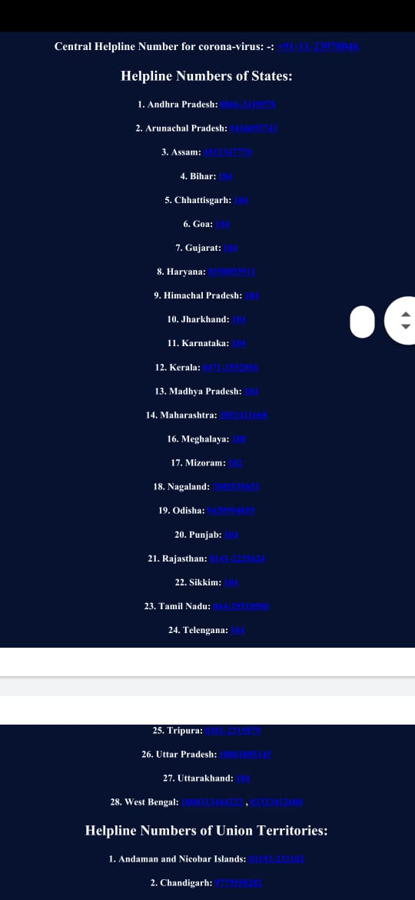

***Emergency Numbers Module Screenshots***

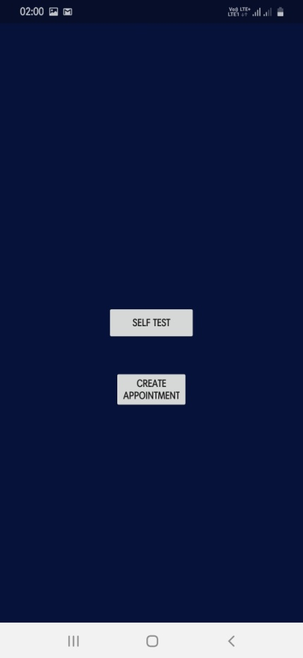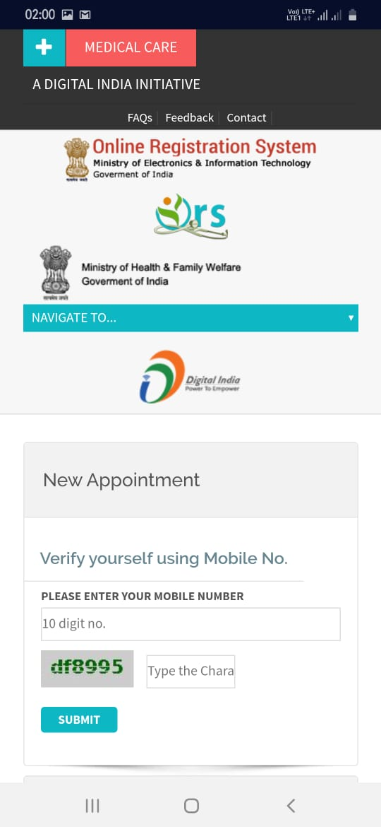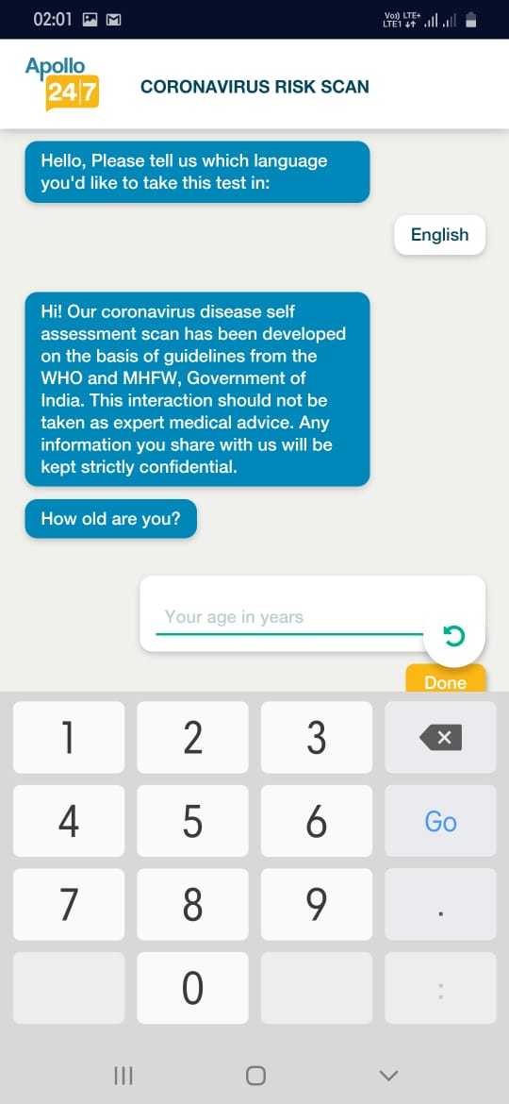

***Create Appointment & Self Test Module Screenshots***

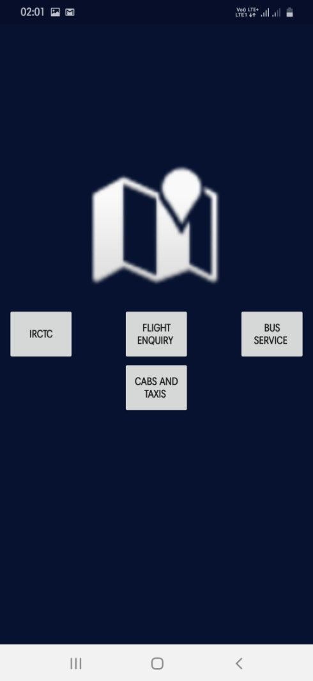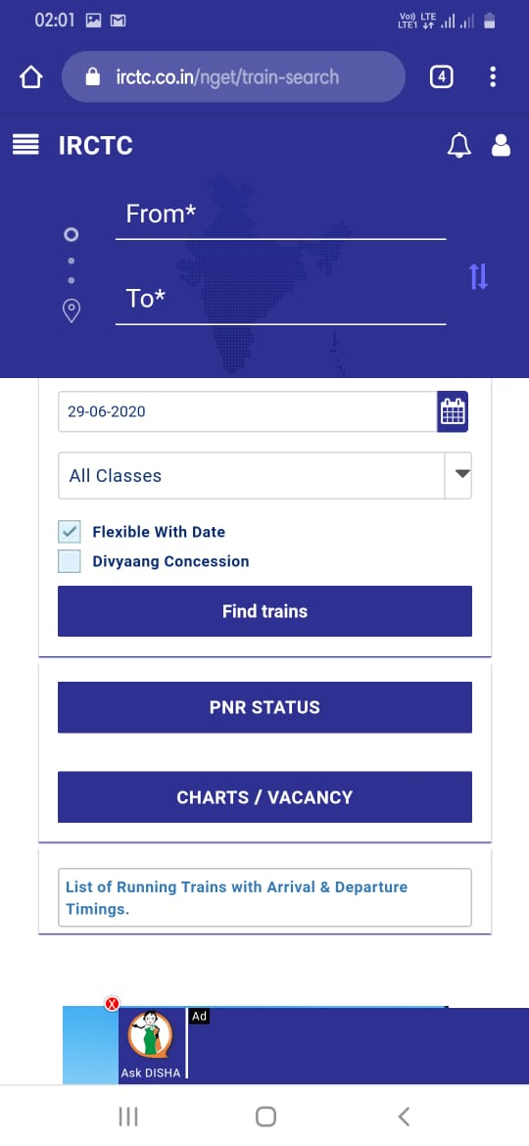

***Transport Module Screenshots***

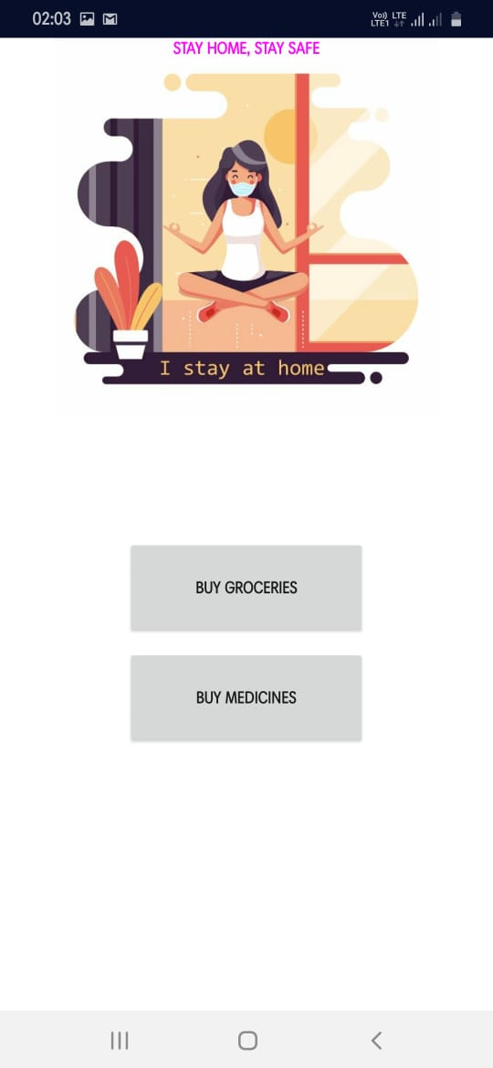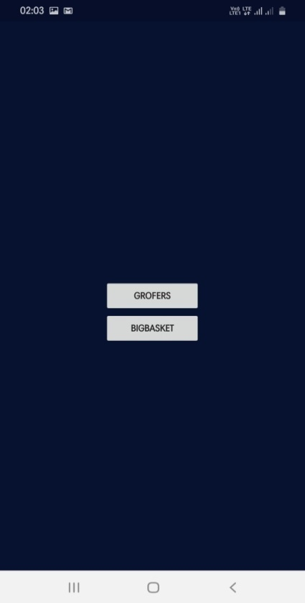

***Buy Items Module Screenshots***

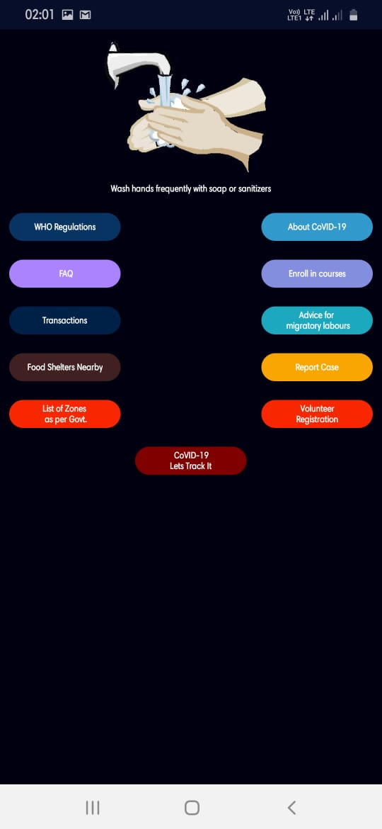 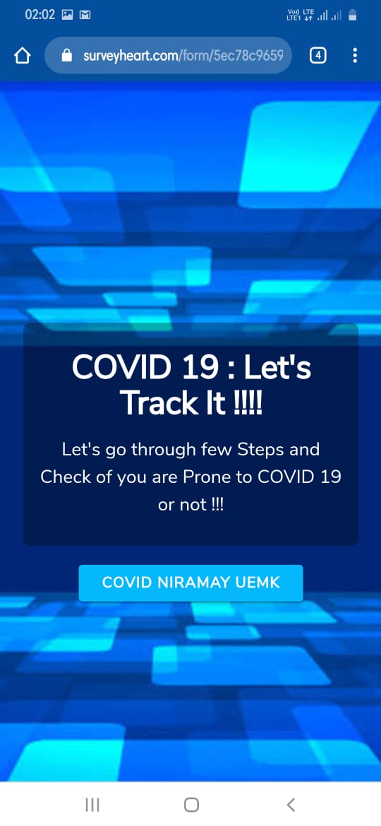 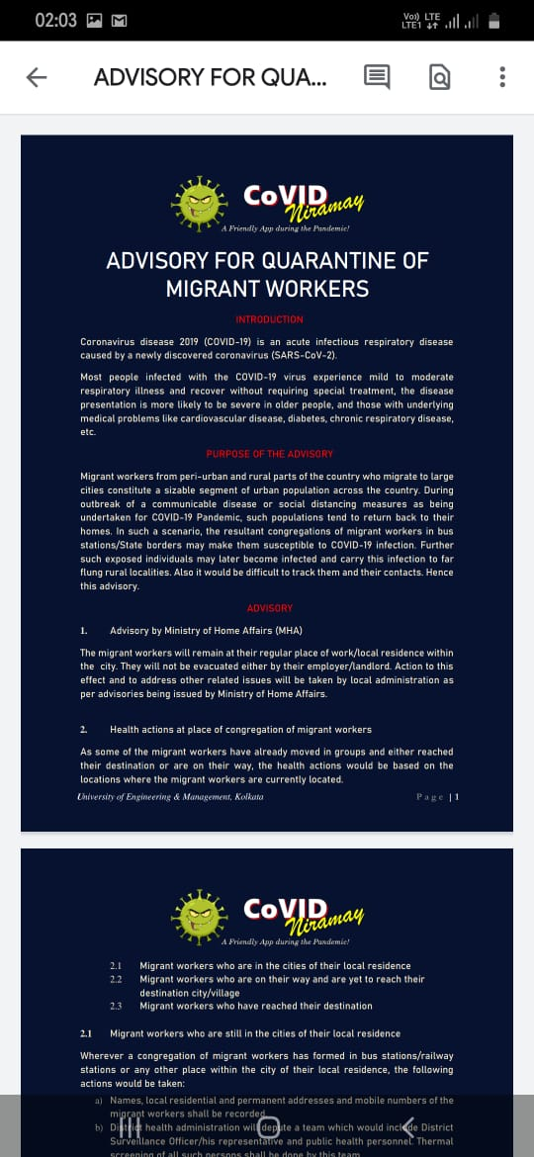

***“More” Module Screenshots***

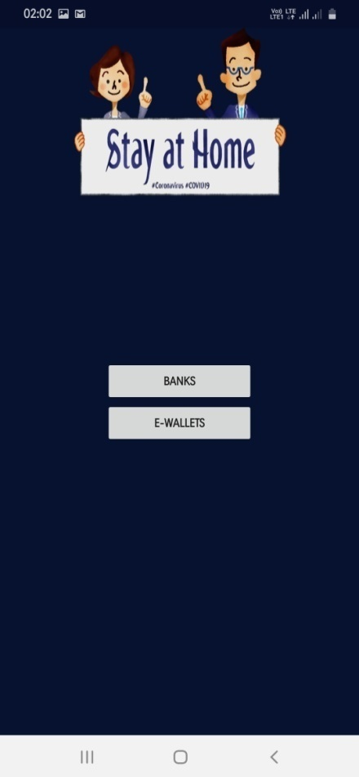 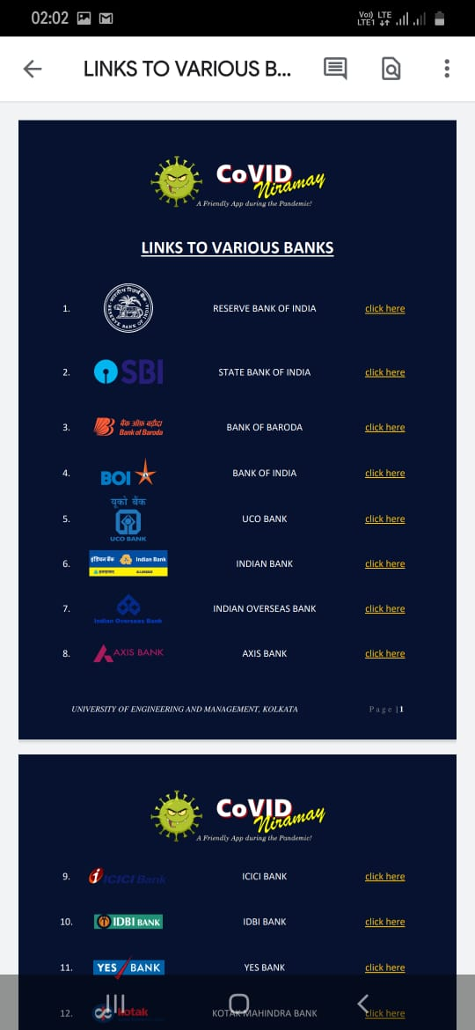 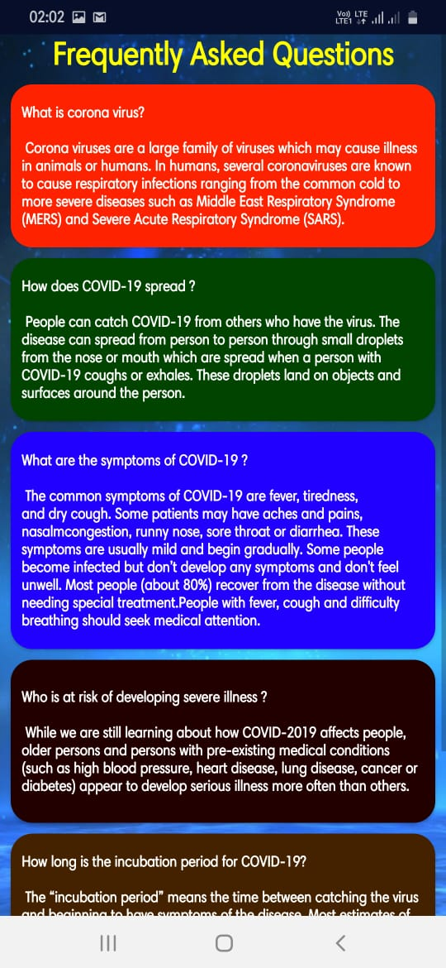

***“More” Module Screenshots***

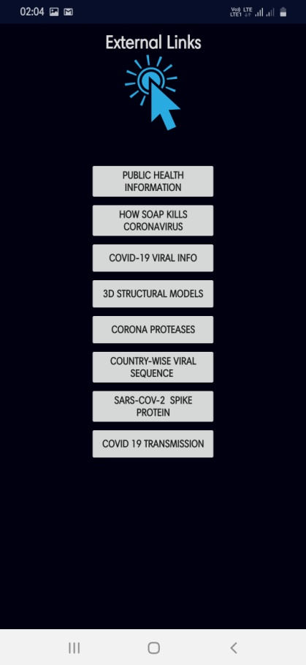 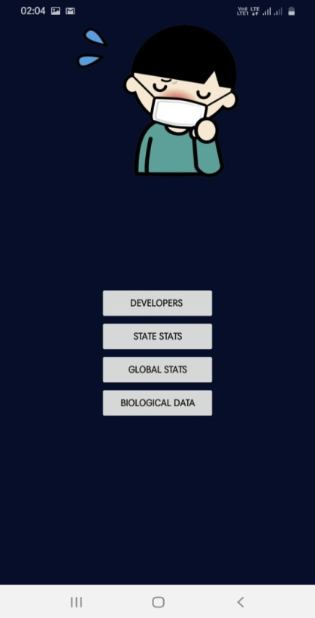

***Biological Data Sub- Module Screenshots***

* **ACKNOWLWDGEMENT OF THE DIFFERENT EXTERNAL LINKS AND APIs USED IN THIS APP –**

We would like to acknowledge the following websites, which have been used in our app:

* <https://lottiefiles.com/coronavirus-animations?page=1>
* <https://www.coronavirus.gov/>
* <https://directorsblog.nih.gov/2020/03/26/genomic-research-points-to-natural-origin-of-covid-19/>
* <https://www.ncbi.nlm.nih.gov/>
* <https://www.youtube.com/watch?v=s2EVlqql_f8&feature=youtu.be>
* <http://pdb101.rcsb.org/motm/242>
* <https://www.covid19india.org/>
* <https://www.worldometers.info/coronavirus/?utm_campaign=homeAdvegas1?%22%20%5Cl%20%22countries>
* <https://www.rcsb.org>
* <https://www.livemint.com>
* <https://www.groferrs.com>
* <https://www.pharmeasy.com>
* <https://www.BHIUPI.com>
* **DEVOLOPERS OF THIS APPLICATION –**



* We would lke to acknowledge and thank our teachers , **Prof. Dibyajit Lahiri** and our respectable HOD [ Head of the Department of Biotechnology , UEMK ] **Dr . Susmita Mukherjee** for their constant guidance and assistance in completion of this Application .
* **FUTURE PLANS OF THIS APPLICATION -**
* **After building this app , currently we have started building a Responsive Website of this App .**
* **This website will consist of all the modules and sub-modules of the App in the same order of the App Interface .**
* **We are hopefull that we will complete our website development by the Middle of the month of July.**
* **Primarily we have also developed a website , which contains details of every Hospitals , Ambulance Service Agencies and also Blood Bank , Police Station , General Help-line number ; details of all the 28 States and 7 Union Territories of our Country . The website is incorporated in our App and also will be incorporated in our Responsive Web .**

**The link of this website is :**

[**https://e2zgvxtogrr6cnmpqfzorw-on.drv.tw/covid/**](https://e2zgvxtogrr6cnmpqfzorw-on.drv.tw/covid/)

* **LINK TO DOWNLOAD THIS ANDROID APPLICATION (Cntrl+Click on the image to download the App)-**

**[](https://drive.google.com/file/d/1-9cFzkCfGGJr3fPNsyxpUv_9OI3oK8EB/view?usp=drivesdk)**